Core Skills learning portfolio



Name: Wesley van der Gragt
Class: ECM1V.EA02
Version: 1
Lab teacher: Rene Heijnen
Date: 29-9-2025
Table of Contents
Core Skills learning portfolio 1
Introduction 4
Week 5 5
Goalsetting 5
Long-Term Plan 6
Information Literacy 6
Critical Thinking 7
Week 6 8
Planning methods and Tools 8
Review Time Management 9
Monitoring 9
Pomodoro 9
Information Literacy 10
Week 7 11
Written Feedback 11
Verbal Feedback 12
Round 1 (Received feedback): 12
Round 2 (Given feedback): 12
Evaluate 12
Reflect 12
The new cycle 13
Asses goalsetting: 13
Key Insights 13
Week 11.1 14
Evaluate 14
Reflect 14
Goals for learn-reflect cycle 14
Planning TODO 14
Monitoring TODO 14
Change habit TODO 14
Procrastination 14
Week 11.2 15
Reflection questions Project New Frontiers TODO 15
Kanban/Scrumboard 16
Discussion on Project management tools & methods TODO 17
Week 12.1 18
Avoid conflicts 18
Reflection questions 19
Push/Pull 20
Reflection questions 20
Thomas Kilmann test 21
Reflection questions 21
Self-Assessment 22
11.2 24
Team communication goals and agreements 24
Reflection questions of previous projects 25
Kanban 26
Discussion on Project management tools & methods 26
Week 12.2 28
Analyse the commercials 28
Debate 29
Week 13.1 31
Research meetings 31
Analyse Scrum Ceremonies 31
Belbin Roles 31
APA 33

Introduction
My name is Wesley van der Gragt. I finished secondary school with a HAVO degree in Heerhugowaard and after that I did a year of Saxion CMGT with the old curriculum. For the year I did with the old curriculum, I gave a lot of suggestions and feedback for assignments and projects that were given in each semester. With coming back to Saxion CMGT, I hope to learn better programming skills and broaden my skills by also learning how to 3d model.

Week 5

Goalsetting
• How do you learn best?
At school.
• How are you doing now at the beginning of your studies?
Doing fine.
• What kinds of strengths do you have?
Able to focus on one thing for a long time
• What kind of challenges or development needs do you have
regarding your studies?
Be able to have a greater understanding in programming and learn how to model well.
• What kinds of career aspirations do you have? / What do you
like to focus on during your studies?
Having both skills in programming and modelling
• How do you ensure that your studies progress well?
By doing the tasks, projects and self study.
• What else do you do besides your studies?
Working in a restaurant.
• How do you relax when you are not studying?
Watch YT or play some games with friends.
• What things are meaningful to you in life
Goal 1: Finish all projects atleast 3 days before their deadlines.
Goal 2: Stream 2 times in a week set on specific days.
Goal 3: Learn and cook new recipes.
Goal 4: Go to bed at 11pm and wake up at 10am.
Goal 5: Work on assignments/projects at school during weekdays.
Goal 6:
Goal 7:
Family and friends

Long-Term Plan
Portfolio assignment:
• Note the deadlines for this semester (formative and summative)
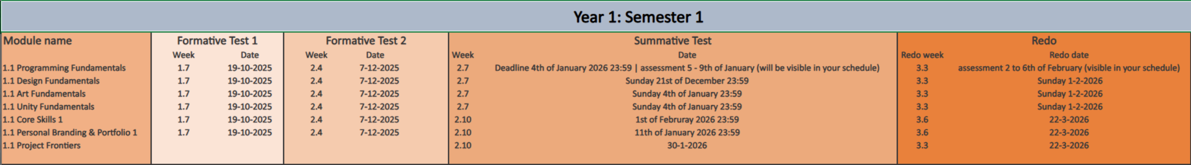
• Plan milestones for your long-term goals.
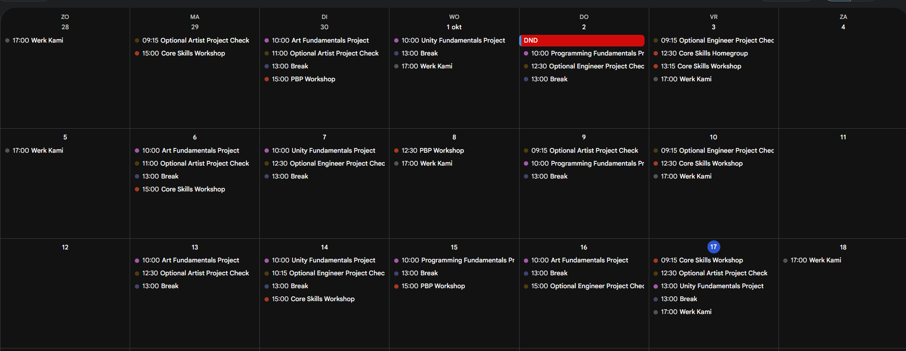

Information Literacy
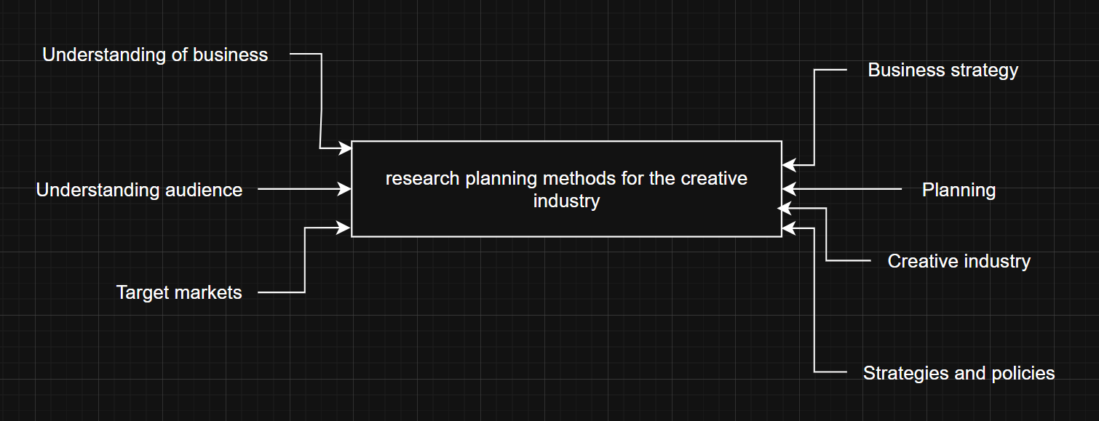
https://www.sba.gov/business-guide/plan-your-business/market-research-competitive-analysis
https://www.researchgate.net/publication/228360972_Creative_methodologies_for_understanding_a_creative_industry
https://portalcris.vdu.lt/server/api/core/bitstreams/741bf8d4-f78a-4f92-ac9c-6ea7cd88c7ee/content
https://www.ucop.edu/local-human-resources/_files/performance-appraisal/How+to+write+SMART+Goals+v2.pdf
https://www.tessr.us/post/planning-as-an-artist
https://www.investopedia.com/terms/s/swot.asp

Critical Thinking
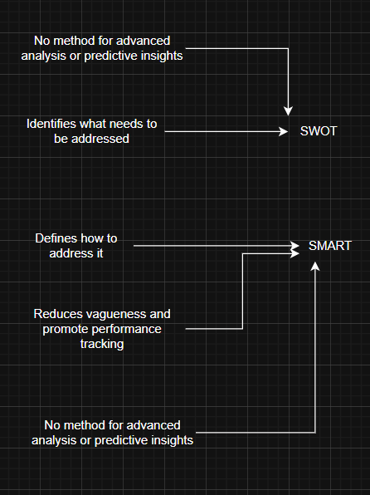

Week 6

Planning methods and Tools
• What methods did you find?
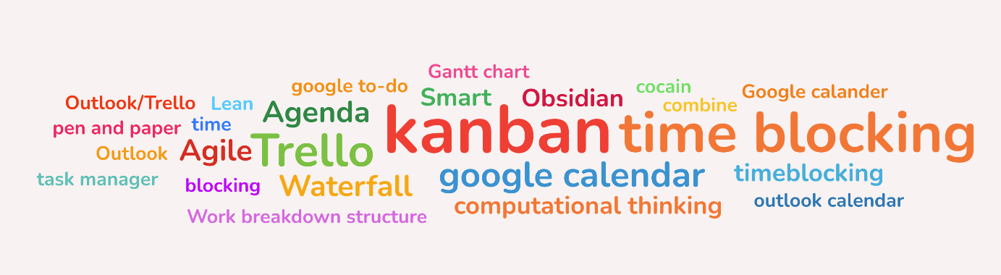
• Which methods could you use for your own planning? 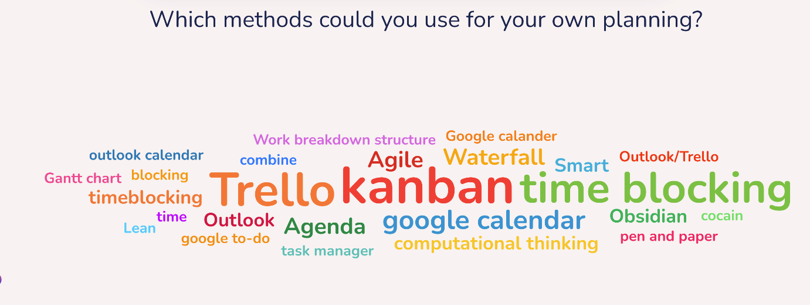
• What would be useful in group projects? 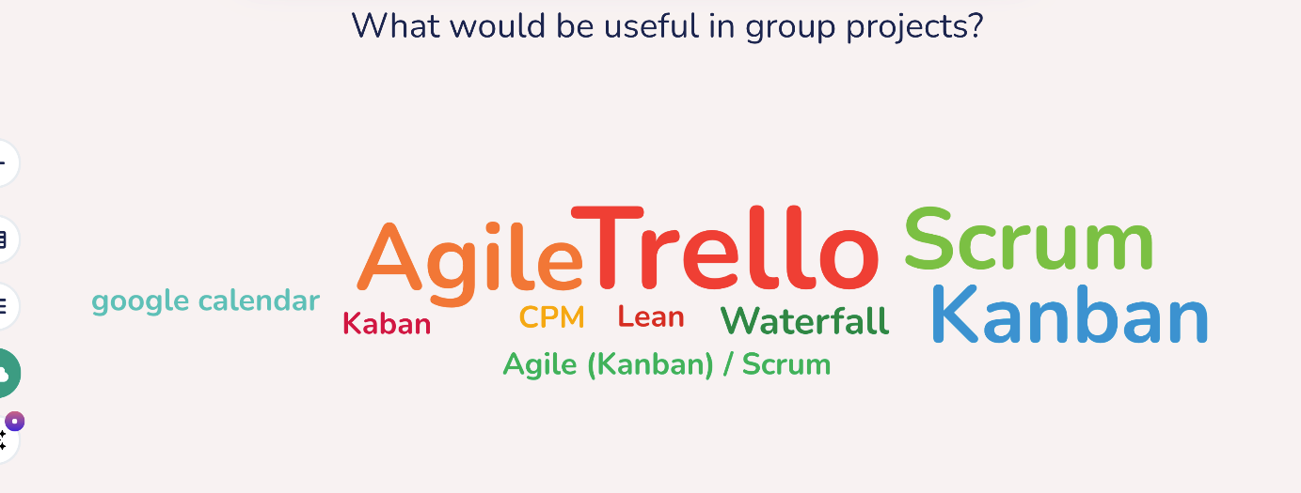+Discord
• What other insights have you gained that are worth sharing
None.

Review Time Management
o Did you use your time as planned?
I didn’t follow the planner at all.
o When did it go well?
When I actually did the work.
o When did things go differently than planned?
By not working it at school I got distracted more.
o What did you spend your time on then?
Games and YT
o Which topic did you find easy to work on?
I’ve only done art fundamentals.
o Which topic did you try to avoid? / Had difficulties with?
None really.

Monitoring

Pomodoro
• Is Pomodoro a method you can implement in your
workflow?
Yea.
• Is it hard to get started with tasks? Why?
Yes, because of too many distractions at the start I cant really start.
• How do you protect yourself from distractions?
Close discord.
• How do you balance being active and resting?
I don’t balance it.
• What is a good way to take a break in between?
Having some food and a drink. Doing something else.

Information Literacy
Best-Worst according to CRAAP:
https://www.investopedia.com/terms/s/swot.asp
https://www.ucop.edu/local-human-resources/_files/performance-appraisal/How+to+write+SMART+Goals+v2.pdf
https://www.sba.gov/business-guide/plan-your-business/market-research-competitive-analysis

Week 7

Written Feedback
I received the following feedback:
Goalsetting: Insufficient
The 2 goals you set aren't very specific. What is all your projects? What exactly does spreading the work load mean?

Planning: Sufficient
Shows time blocking for doing homework, but it's not specific about what tasks you'll work on

Research: Insufficient
You didn't provide your own findings

Monitoring: Sufficient (i think)
You show the burndown chart

Documentation: Insufficient
Going from Week 5 to 5.2 looks confusing, consider keeping this consistent by using 5.1 and 5.2 instead. I don't see any evaluation of sources

Tip:
See feedback

Top:
Great start, I think you just need to do your todos and it'll look fine

Feedback I gave:
Tip:
Inside the planning it only says to work on anything. So it doesnt give a clear view on what is most important to work on.

Top:
Everything has a nice clear structure and a good summary of what was done in the week.

Verbal Feedback

Round 1 (Received feedback):
Tip: Make images readable (Not zooming in to read)

Tip: Look up if u gotta APA selfmade Images.
Or larger at the APA.

Top: Good layout
Tip: Do assigments the day off. (Or next day)

Tip: do summaries

Round 2 (Given feedback):
Feedback they received:
Top:
Portfolio has potential. it has good foundation and layout already.

Tip:
I think it would be best to have the assignments completed on the day they were given, instead of postponing it.

Tip they received:
Ctrl enter to set words to next page without spamming a bunch of enters.
Numbering of the appendix and try to figure out the thing with the link.

Evaluate
After creating the planning I didn’t approach it at all. I should’ve done it since I didn’t have all my projects done at the end of the deadlines. It might have also helped with achieving my goals which most of them I didn’t achieve either.
I did find out that working at home doesn’t work for me. But when I do start working I should at least turn off my phone and put on some music.

Reflect
After the project weeks ended I found out that by working while having my phone off and listening to music is the best way I can work and the hardest part was the part of starting to work on everything.
But when I do start working on things I usually work till I don’t know how to fix something or how to do things.
And for my study habits I should start waking up earlier then usual and work on the things I got to work on.
Do my assignments when I get them and also work at home if its not done yet, stop procrastinating on projects and use a graph to monitor my performance throughout the week.

The new cycle

Asses goalsetting:
• Formulate the positive outcomes.
Goal 1(Finish all projects at least 3 days before their deadlines.):
I will have enough time to fix, and improve the project before handing it in.
Goal 2(Stream 2 times in a week set on specific days.):
A personal goal to be able to work on my talking skills and more interactable.
Goal 3(Learn and cook new recipes.):
By being able to make more diverse meals, I can be more healthy.
Goal 4(Go to bed at 11pm and wake up at 10am.):
I will have more time to be able to do things during the day and be less tired.
Goal 5(Work on assignments/projects at school during weekdays.):
This will make sure that I have completed my assignments and projects before the deadlines are due.

• Set clear goals to address the issues you uncovered in the
evaluation & reflection, helping ensure better results next time.
Added goals:
- Fix sleep schedule
- Work on assignments/projects at home during weekdays.

• Think about the purpose of the goals. Do you want to gain
knowledge, skills (learning) or is it more about your performance
or social aspects?
The purpose of goals 1 and 5 is to make sure my performance is good in school.
The purpose of goals 3 and 4 is to be more healthy and have better skill in cooking.
The purpose of goal 2 is to have a more social stand and build skill in editing and socialising.

Key Insights
A website to show your tasks and what has been done.
Some people find that they work better without having a premade plan.

Week 11.1

Evaluate
For the past 3 weeks I haven’t created a planning, but I did complete all my assignments within the lessons and worked a lot on the projects after the bootcamps were done.

Reflect
I should have also worked on the days where I didn’t have any bootcamps and still go to school to work there.

Goals for learn-reflect cycle

Planning TODO

Monitoring TODO

Change habit TODO

Procrastination
• Do you procrastinate or have difficulties with motivation?
Yes.

• Which procrastination type(s) sound most like you? And why?
The Relaxed Procrastinator, Because I often feel calm even until there is just a day or 2 left before the deadline and I think tasks take much less time then they actually would take.
The Lone Wolf, Because I usually only ask questions until I have tried multiple solutions myself. Looked it up online and see what else could cause it.

• What’s one concrete strategy you can try this week?
Ask teachers questions on what I don’t know instead of searching everything online.

• How do stress, uncertainty, or sensory overload affect your motivation?
If I do get any of those I usually don’t do anything to what I need to do.

• Who can you ask for feedback or support before you hit a wall?
Other students and teachers.

Week 11.2

Reflection questions Project New Frontiers TODO
• Which general positive and negative experiences do you
have with teamwork?
For bad experience a lot of arguing in the group and people not doing their work.
For good experience, good teamwork and communication.

• What specifically annoyed you during previous projects?
Arguing even though the person is working well, even though its at home.
People not doing their work properly and on time.

• How could you have prevented this/addressed it early on?
By telling them that they should work on the parts that has to be done.
And trying to say it more times that they are working fine.

• What are some things you need to work on yourself?
Telling my opinions more then just going along with others.

• Provide a brief overview of the communication aspects that
you consider important and plan to utilise in the Frontiers
project

Kanban/Scrumboard
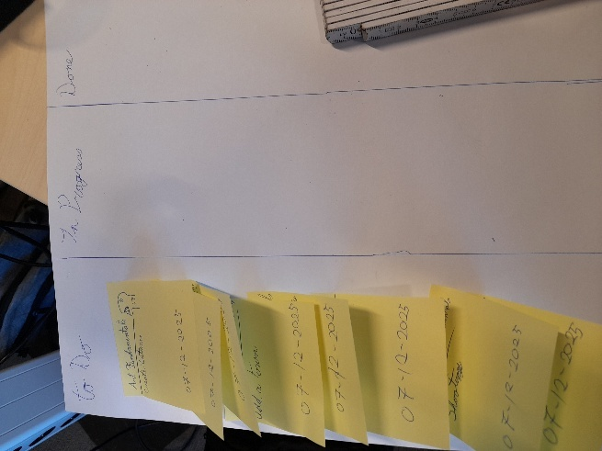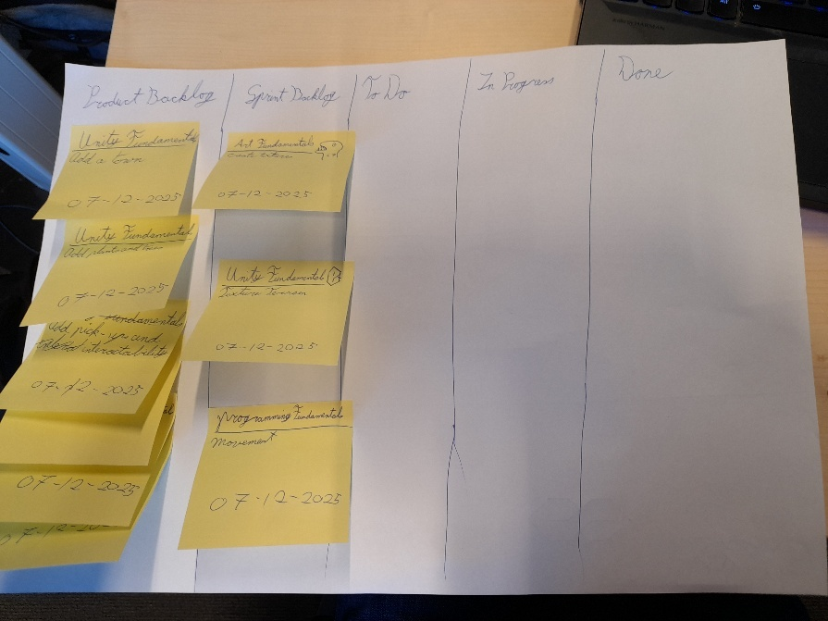

Discussion on Project management tools & methods TODO
• How did the teams you were in before organise work?
• What kind of workflow or system would help you keep track of
progress and responsibilities better?
• What aspects of Scrum sound useful for your team? (e.g. sprints,
daily stand-ups, retrospectives, user stories, burndown chart)
• What aspects of Kanban sound useful? (e.g. visualising workflow,
WIP limits, cycle time tracking, cumulative flow diagram)
• Would a mix of both make more sense? Why or why not?
• How can you make sure the system actually helps you improve
continuously?

Week 12.1

Avoid conflicts
Group project poster!
• What do you notice about the overall “profile” of your group?
In the group we a had a lot of cards on the col. Clarify side. It was very noticeable that people liked clear rules and structure.
• Where are the clusters and where are the outliers? –
• Take one of the clusters and discuss why these needs are important, what happens if this isn’t respected, and what others could do to support
we discussed col. Clarify part.
When someone doesn’t do their work then talk to them how you can either help them or why and where it goes wrong.
Give each other support and understanding. If there is no clear communication then there is a possible disconnect in the group and the final product may not match in the end?

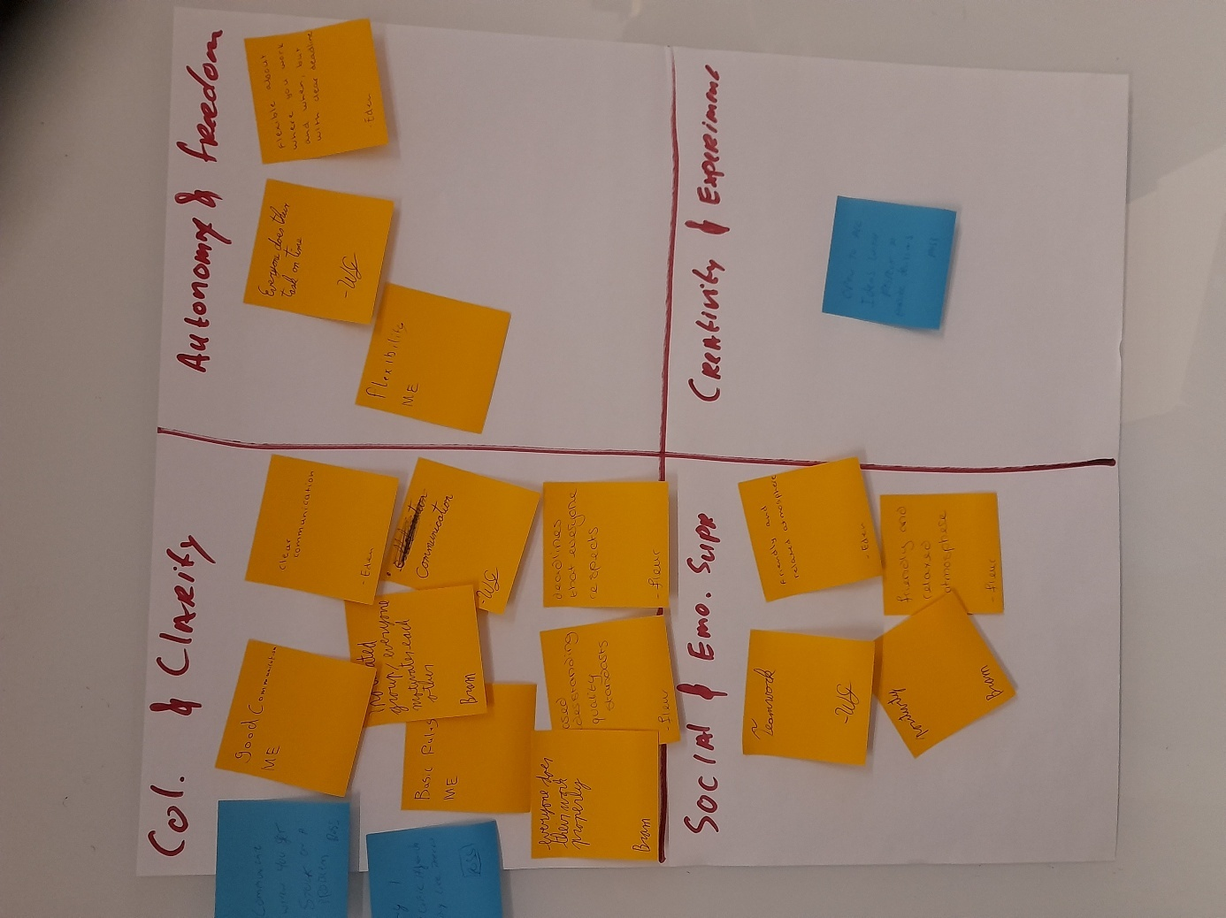

Reflection questions
• My top 3 needs in teamwork are…
Teamwork, Communication and everyone doing their tasks.

• What others can do to help me work well is…
Give me clear instructions on what to do and check in sometimes.

• What I can do to help others work well is…
Asking what has been done/doing and what needs to be done.

Push/Pull
Case 1 (Your teammate hasn’t uploaded their
part of the group assignment. The
deadline is tonight):
• Which behaviours did I see?
Bram: Asks why the task isn’t submitted yet. (Pull) : Asks question to know why something happened.
Jordan: Answers it by saying he will submit it. (Pull)
Bram: Asks why no time to finish (Pull)
Jordan: Answers by overthinking and thinking things are going wrong (Pull)

A lot of understanding and being civil

• How did it affect tone, tension?
It was a friendly tone with asking and understanding.

Reflection questions
• When did Push feel effective? When did it create resistance?
- When you suggest things to the other person to help them out somehow.
- When interrupting someone and knowing better.

• When did Pull create understanding or calm things down?
Asking questions made it slow down and have less tension.

• What type of feedback or situation tends to trigger your push
reactions?
When the rest of a group cant figure something out.

• How can you use Pull next time to understand what’s behind
someone’s behaviour?
By asking questions and/or summarizing

Thomas Kilmann test

Reflection questions
Using the test I found out I am Avoiding and accommodating

• Reflect on your conflict style(s) based on two
different life or work situations.
When there is high conflict/tension I usually just shut down. And don’t know what to do.
When there are choices I usually go with the rest of the people.

• How do you react or cope when conflict situations
arise?
With conflict I either get angry or I stop talking and my mind goes haywire.

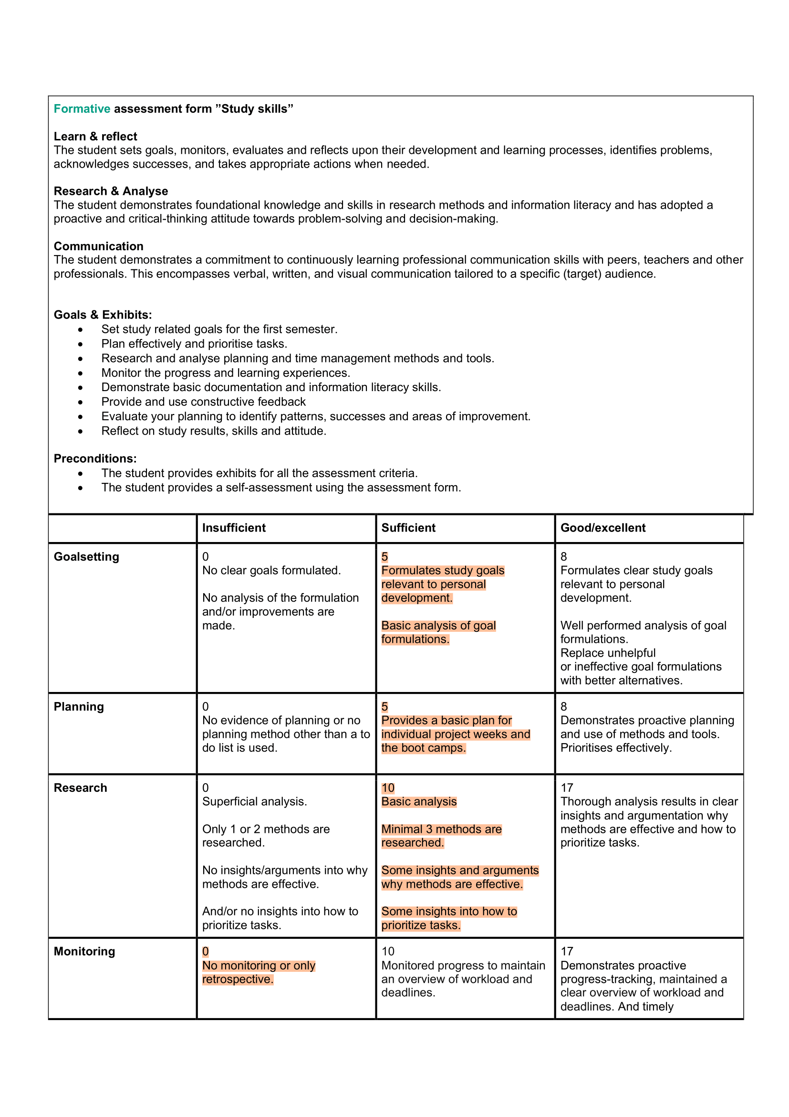
Self-Assessment
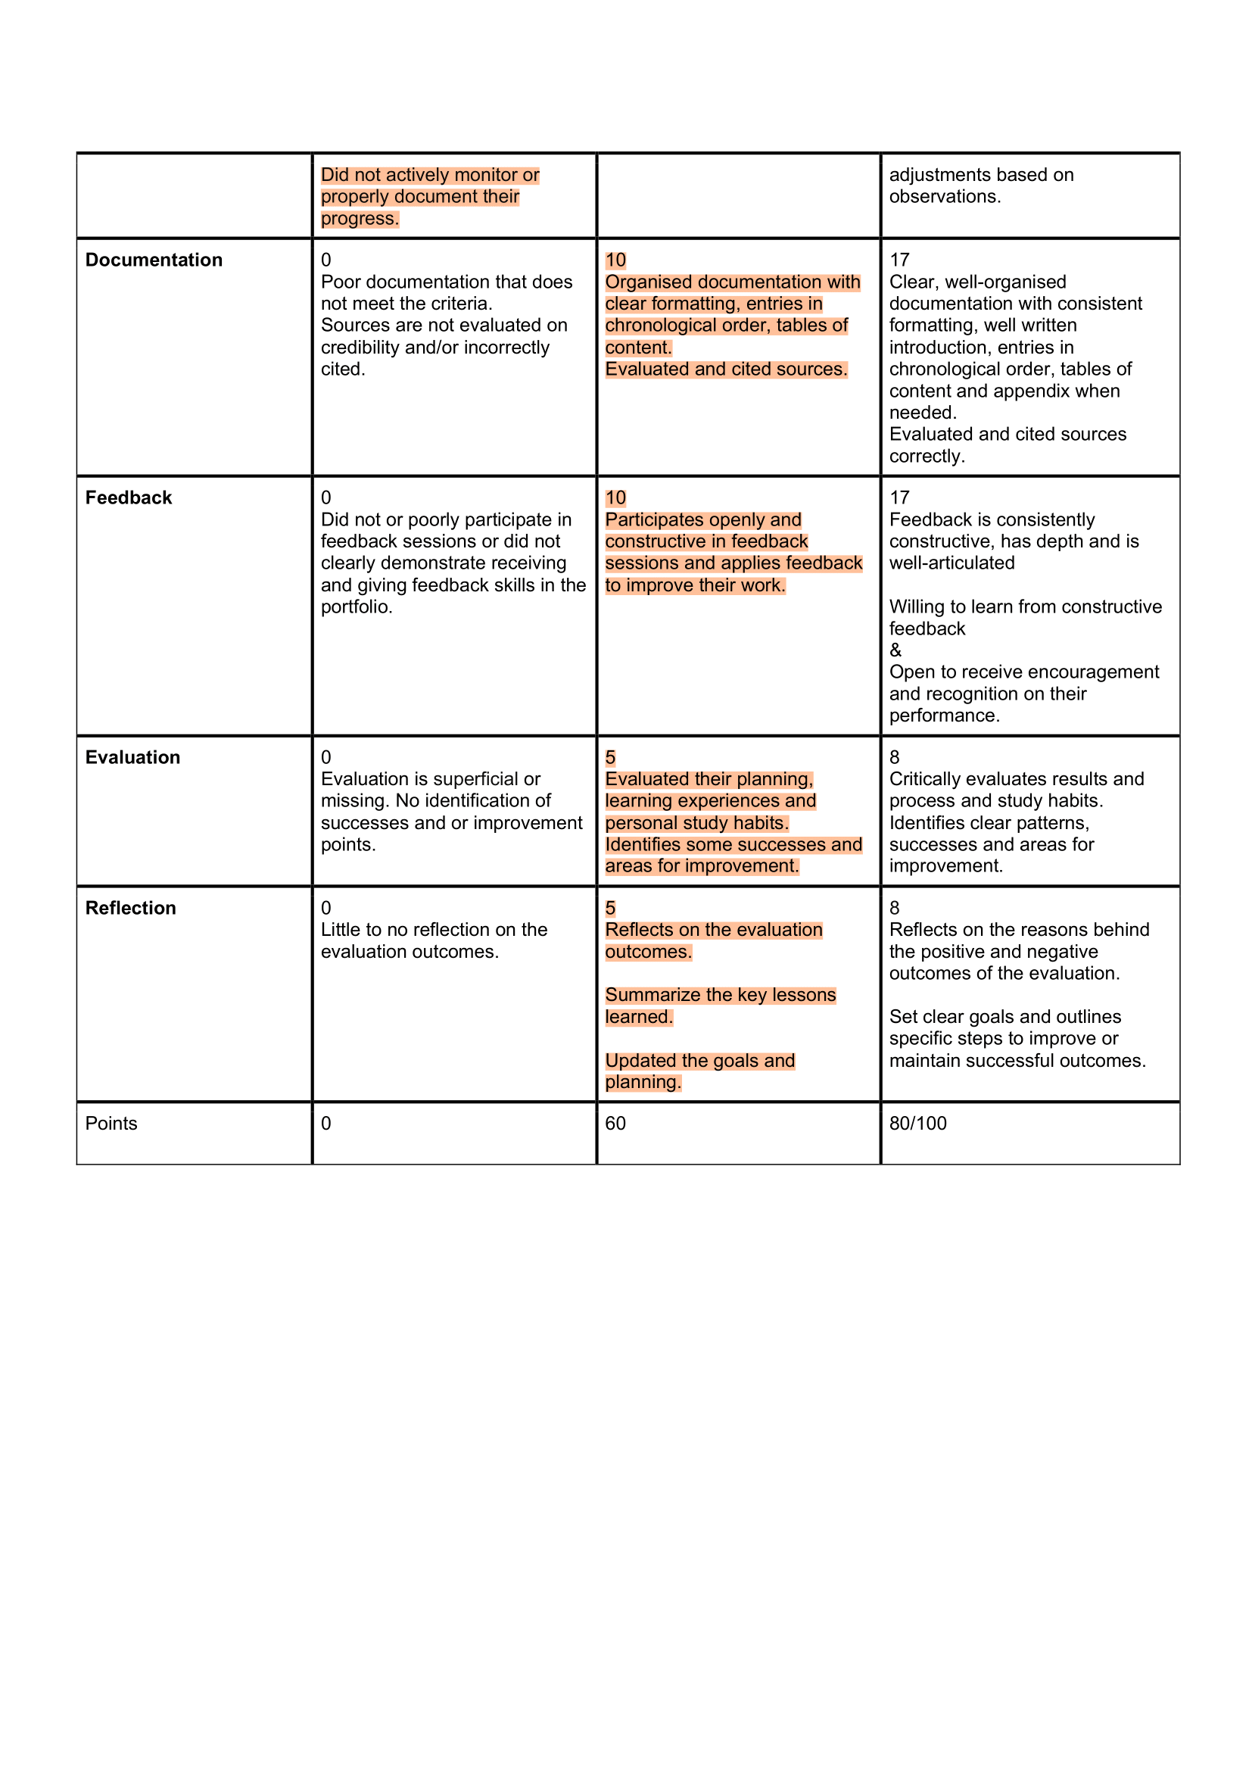
Reasons:
Goalsetting: These goals are personal for what I would like to achieve and are able to achieve in short term.
Planning: I’ve made a planning in google calendar for the 3 individual project weeks with tasks to do and fixed things that will happen those days.
Research: I made a argument map about 2 basic methods you could use for planning in the creative industries.
Monitoring: I forget to put in what I have done in the graph and have to remember what to do after remembering a few days later that I have to fill it in.
Documentation: Everything is in chronological order with a clear structure.
Feedback: I’ve given feedback from what I found to be. For the written feedback, it was quite hard to give tips in what to do since I was given a very well documented learning portfolio.
Evaluation: I identified some problems in my study etiquette and personal life. So I made those into goals I want to achieve in the upcoming weeks and placed them in my goal list.
Reflection: Updated the goals with 2 new ones and reflected on each goal I have separately.

11.2

Team communication goals and agreements
• Is a Team leader necessary? How should they be chosen?
(volunteer/elected?) What should their tasks be?
- Its good to have it one.
- Volunteering, being elected or voting on who becomes it.
- Keeping track of tasks, overviewing how far people are in certain tasks.

• What kind of team rules should be established before the project
starts? What are the possible solutions?
- If you cant finish a task, ask for help.
- Communicate.
- Put maximum effort in.
- Let the team know if you are going to be late to meetings.

• When and how do you set clear objectives? What does this
involve?
- After the first week when the main objectives are clear to do.
- Setting objectives that have to be in the project and change things you need.

• How often should you have meetings and/or updates?
- Twice a week for updates if you are not working with the rest of the team at school (or other place)

• Where should the team communicate and how should it keep
track of its progress?
Discord is good for communication and Trello for the tracking of progress.

Reflection questions of previous projects
• Which general positive and negative experiences do you
have with teamwork?
- Good communication, everyone did their jobs. And the atmosphere was great.
- People not doing their work. Tasks were unclear. I had to help with the controller at the end and did all coding.

• What specifically annoyed you during previous projects?
- People not doing their jobs on time and having to pick up the slack.

• How could you have prevented this/addressed it early on?
- Reviewing team members and giving tasks on what each needs to do on that day.

• What are some things you need to work on yourself?
- Asking for help earlier, and spreading out tasks more.

• Provide a brief overview of the communication aspects that
you consider important and plan to utilise in the Frontiers
project.
- Team rules
- Setting clear objectives
- Updates each weekday.

Kanban
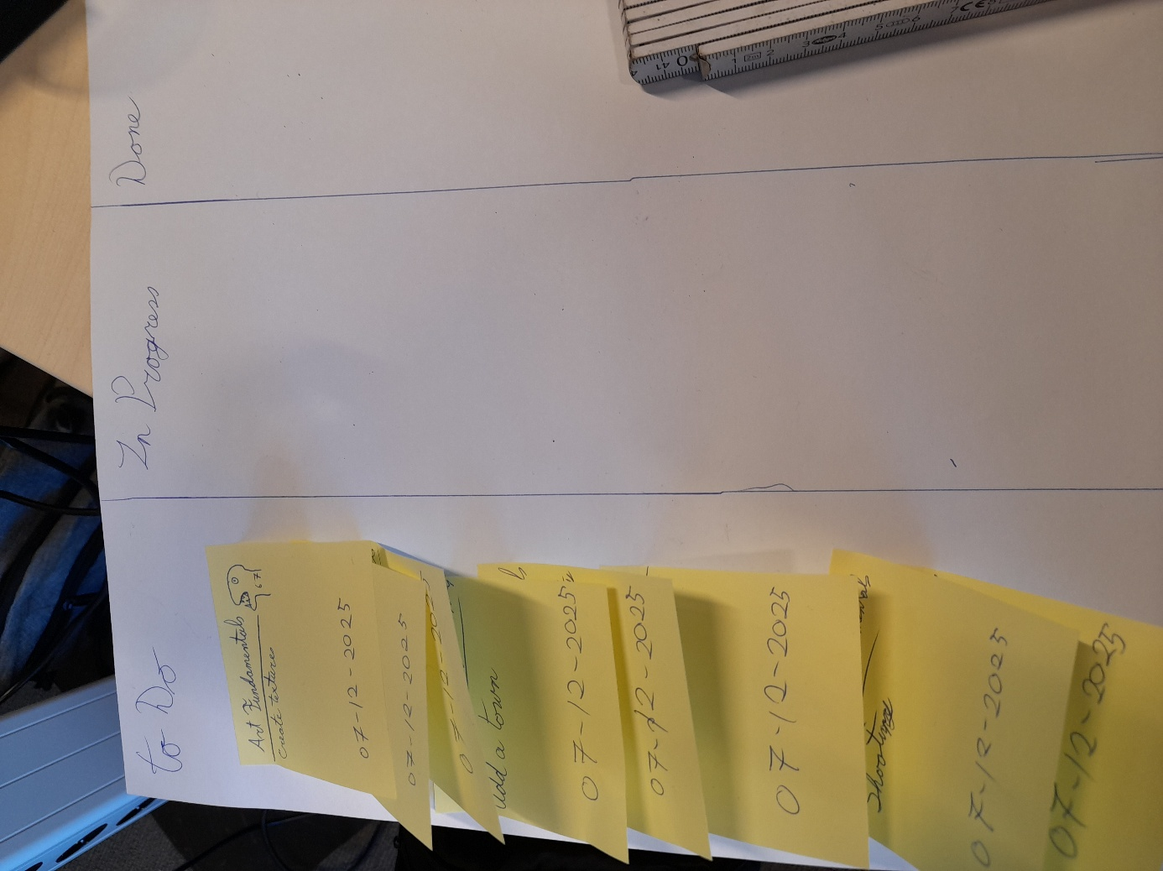

Discussion on Project management tools & methods
• How did the teams you were in before organise work?
Using Trello to show tasks and see which ones are done and what has to be worked on.

• What kind of workflow or system would help you keep track of
progress and responsibilities better?
Scrum

• What aspects of Scrum sound useful for your team? (e.g. sprints,
daily stand-ups, retrospectives, user stories, burndown chart)
Sprints and stand-ups sound useful since it will show all the things you have worked on and what you still have to work on in the coming days.

• What aspects of Kanban sound useful? (e.g. visualising workflow,
WIP limits, cycle time tracking, cumulative flow diagram)
WIP limits, because it only shows you the most important tasks which you have to work on and after completing those it shows the next ones.

• Would a mix of both make more sense? Why or why not?
Yes. Since it will show the most important tasks and also where its at.

• How can you make sure the system actually helps you improve
Continuously?
By setting up a scrum board with a sprint that is 1 or 2 weeks long and doing those things.

Week 12.2

Analyse the commercials
Haynes baked beans commercial https://www.youtube.com/watch?v=eZgD89VYkV
- What is the objective of this ad?
To sell their products.

- What argument(s) does it make?
Even astronauts eat them.

- Where do you see/hear the three rhetorics appeals in the examples
Not much Logos.
Using pathos by having action scenes and humour to grab your attention.
Ethos, because of the brand.

Remarkable commercial https://www.youtube.com/watch?v=SWY_bwFMxro
- What is the objective of this ad?
Showcase the product and sell it.

- What argument(s) does it make?
You can buy all 3.
Want to sound credible and want you to know that if u want to use paper, they are the best way to do it.
Better on your eyes.
Portable.

- Where do you see/hear the three rhetorics appeals in the examples
Ethos, plays a lot on how good they are and give a ton of arguments.
Logos, regards of sizes and credibility with the good components and precise machines.
Pathos, Use music, colours and cinematic scenes to get connected.

Ikea Spike Jonze commercial https://www.youtube.com/watch?v=TsQXQGaasUg
- What is the objective of this ad?
To promote their launch.
Trying to sell you a Macintosh.

- What argument(s) does it make?
It wont be like 1984.

- Where do you see/hear the three rhetorics appeals in the examples?
Logos, saying this is based on a system and giving facts.
Ethos, showing the Apple logo.
Pathos, drag you in using the book 1984.

Ikea Spike Jonze commercial https://www.youtube.com/watch?v=TsQXQGaasUg
- What is the objective of this ad?
Trying to make you buy new things.

- What argument(s) does it make?
Saying the lamp doesn’t have feelings and the new one is much better.

- Where do you see/hear the three rhetorics appeals in the examples?
Logos, arguing that objects don’t have feelings.
Pathos, the music is immediately sad.

Debate
Arguments see file DebateText.txt
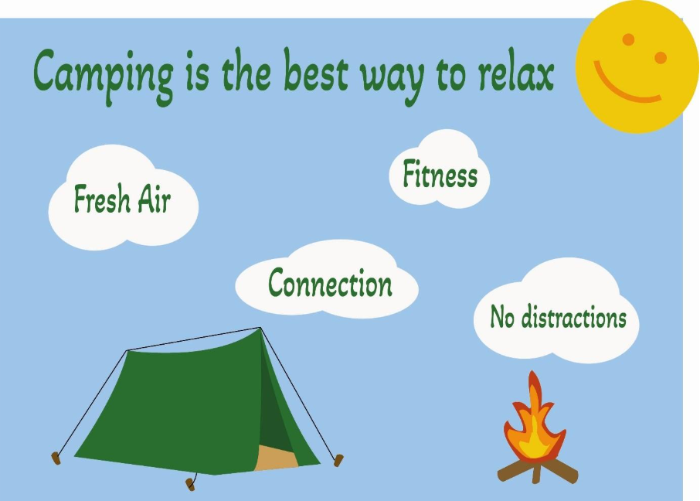

Week 13.1

Research meetings
See “Research Meetings.docx”

Analyse Scrum Ceremonies
• Note per ceremony, how you could benefit from
using this ceremony during the New Frontiers
project.

Sprint Planning Meeting: Clear objectives to achieve within the time of a sprint with estimated times to finish each tasks and talk about risks and such.
Daily Stand-Up: Good info on what has been done the previous day and what will be done today. Gives clear information about each days goals.
Sprint Review: Will show what was done right and what needs to changed, Easier to make prototypes of different kinds of systems and make changes to it before making it official.
Sprint Retrospective: Works more towards the emotional wellbeing of the workers and teamwork.

• Note also whether you do or don’t want to use the
ceremony and why.
Use sprint planning meeting, since it gives clear goals to do within the time of a sprint.
Use Daily Stand-Up, because it shows you what has to be done and what has been done previous day.
Don’t do Sprint Review, because I don’t think we would have a lot of time to make a ton of prototypes and still put it in the game.
Don’t do Sprint Retrospective, since doing it mid project it would be harder to finish the other tasks.

Belbin Roles
• Which role feels most natural for you?
Teamworker, Because I usually go along with other peoples ideas and don’t like confrontation at any level.

• Which role would you like to try in the
next meeting you participate
Implementer, Because usually I want to go into the programming side so I would need to do the logistics and execution.

Week 13.2

Reflection
What went well and what didn’t go so well?
Everyone spoke clearly. The meeting should’ve been done a bit differently.

What role did you play?:
I played as Developer and it went pretty well. Only thing was that I had not checked what “Tasks” I had inside the Trello.

Feedback Received:
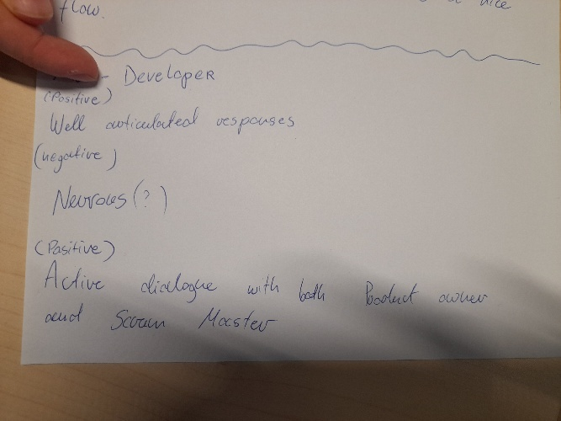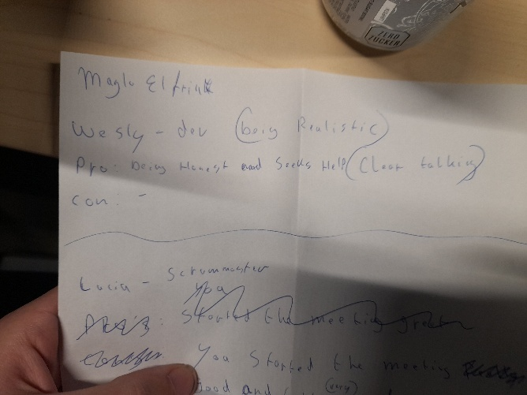
(From Lucia) (From Maylo)

APA

